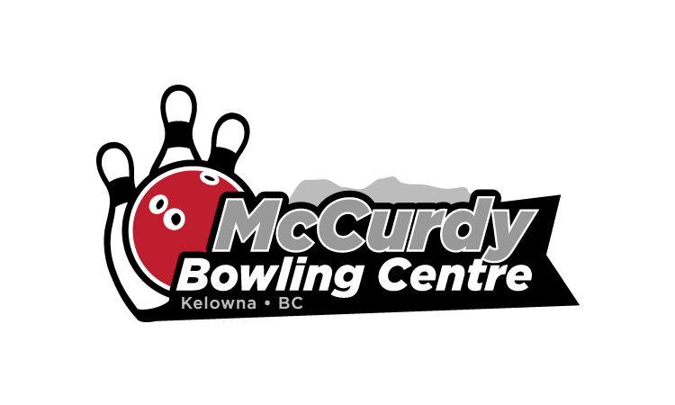
2021/2022 Youth League Bowling Information
To confirm, or reserve your spot, call Kim Bunnage @ 250-491-2695, or email her at kim@mccurdybowl.com. All Info is available on our website www.mccurdybowl.com.
WE ARE READY TO GO……September 11/21 @ 10am………..Youth League begins

- Please call or email if you are planning participating this season
- Please list who you would like to bowl with on your team
- Food service will be available @ 10am
- Lineage is $15 weekly (tax included)
- Coaches will be available.
- League play is back to normal with no special restrictions
- Registration fees are still to be determined. (approx. $55)
- Bring a friend or two with you this season and help the program grow.
Call 250-491-2695 or email kim@mccurdybowl.com to let us know you will be participating. We will handle the official registration on September 11/21
Youth Bowling Camp Aug 17-20 (4 days). The camp will run 1-3pm each day and the cost is $45 per person.

Don’t wait until the last minute to get your equipment tuned-up, make an appointment with Merlin in the pro shop before league starts.

Welcome back!

